**Donate-able Items:**

* Crayons
* Coloring books
* Colored Pencils
* Paper
* Sketch pads
* Mess-Free crayon and pencil sharpeners
* Crayola TM Color Wonder products
* Etc.

Please do **NOT** donate…

* Used materials of **any** kind
* Paints
* Sharpeners without shaving-catchers
* Markers

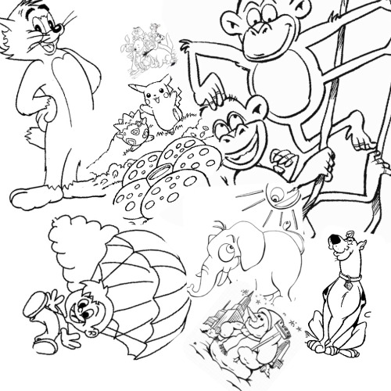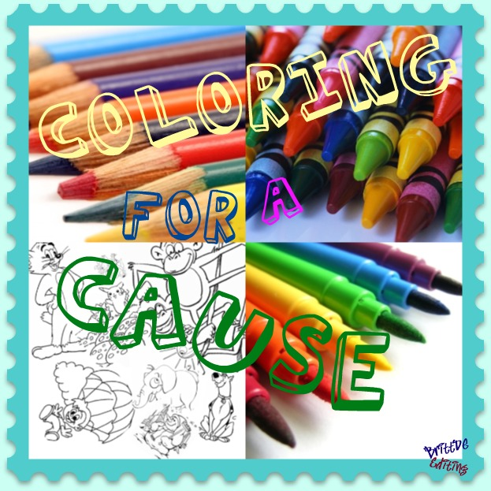

**Coloring for a Cause****C** is a charitable, **non-profit** organization looking to collect coloring and drawing supplies to donate to children’s hospitals and Ronald McDonald Houses annually throughout the year. All participants are volunteers and all proceeds are donated or used to purchase donate-able items.